
2026-2027 Season
Avon Quarterback Club Parent Packet
Purpose
The Avon Quarterback Club is a not-for-profit group made up of volunteer parents, guardians, and coaches that believes deeply in the success of our student athletes. We recognize that in order for our football program to continue to be successful, it takes coaches, students, parents and strong community support to join forces. The AQC needs YOU to help make it a successful season.

What do we provide?

🏈 Pre/Post Game Meals — 180+ student athletes, managers, trainers, coaches

🏈 Thursday Night Team (TNT) Dinners — Sophomore, Junior, and Senior players, Cheerleaders, Managers, Coaches, and Trainers; Freshmen players ONLY at Head Coach's Invitation
- The AQC Hosts a family-style meal directly after their Thursday Night Practice (~5:30pm - 7:00pm)
- All parents/guardians are encouraged to sign up for Teams that will rotate between entrees, sides, or desserts (serves 12) each week to feed the players “family-style”
- There are also PayPal and Venmo links to donate money in lieu of donating a food item

🏈 First Home Game Tailgate — Hosted by the Freshman Parents with a 5:30pm to Kick off.

🏈 Senior Recognition — Provided to Senior Players during the season and at the Banquet

🏈 End of Season Banquet — Early December (TBA) @Avon High School
- This is a wonderful time for our Players, families, coaches and friends to reflect on the Season

🏈 Football Program Support — Coach Gibson sponsored events
- Avon Youth Football Camp, College Night, Oriole Night, Team Equipment and Supplies

How do we provide all of this?

🏈 Maximum $65 Meal Fee —Paid in August to the AQC. Actual amount based on success of fundraisers.
- The Meal Fee is collected in order to provide the Pre/Post Game meals.
- We ask parent volunteers to pick up, transport, and serve the meals to the Team. The Pre/Post Game Coordinator will send out a Sign Up Genius in order for you to sign up.
- This is NOT the same as the Program Fee charged by the Athletic Department.

🏈 Quarterback Club Fundraising - We need everyone's help!
- Big Money-Makers
  - Mattress Fundraiser (Feb 2027)
  - Club Fundraiser- PIZZA (October TBD) - This year we will host a pizza sale! The players will help AQC assemble the pizzas. The players will then take responsibility to deliver the pizzas they sold.
  - Golf Outing (July 24, 2026) - This outing provides about $10,000 in funds. This is our most profitable fundraising event and it takes about 20 volunteers.
  - Coach’s Fundraiser- The Athletic Dept allows each Program to run a fundraiser that requires the participation of each student athlete in their Program. *These funds belong to the Athletic Dept.
- Other Money-Makers
  - Kroger Community Rewards - Sign up so when you shop AQC gets a portion back.
  - Community Day - August; this is an annual event hosted by the National Champion Band Program. They simply ask that we provide Concessions Staff that day.
  - Dine & Donates - Monthly; Dine to donate a portion of sales to the AQC.
  - Concession Stand Duty - August thru May; the Athletic Department assigns all sports with a number of Concession stands that need “manned”. It is the responsibility of the Freshman Families to cover these dates. *These funds belong to the Athletic Dept.

🏈 Stay In The Know! — We are here to help you sort through AQC and the AHS Football Program.
  - www.avonqbclub.com - This is the Club Website and we are working on it weekly to keep it up to date and relevant. The Event Calendar is the most important page.
  - Facebook Page - Avon QB Club Group Page - This is a private group where we will post photos from our Club Photographer. You must answer the membership questions.
  - Avon Quarterback Club emails - These will hit your mailbox ONE time a week with important information from the Club. Provide your email address to get subscribed.
  - Instagram and X - This is where we will Post or re-Post news about our Football Program.
  - Avon Quarterback Club Meetings - These 1 hour meetings occur ONCE a month, typically the 3rd Wednesday, in the Coaches Team Meeting room located behind the stadium.
  - Fan Gear-Apparel, Fatheads, Decals, Yard Signs -Keep an eye out for this year's order form.

🏈 Watch the Calendar/Schedule — This is where you should look first, but then….
- Pre Season Scrimmages - there are several scrimmages during the Summer (TBA).
- Fall Break - There are regularly scheduled practices and games during Fall Break. Be prepared to alter your Fall Break “plans” to accommodate.

Who do I contact?

🏈 Avon Quarterback Club Website — This is where you should look first, but then….
- The attached roster provides a list of the folks leading projects that we do throughout the year.
- Attend the monthly AQC Meetings
- Volunteer! We want to meet you and get to know you!

Board Members 2026-2027

President
Steve Stewart (Senior) | avonquarterbackclub@gmail.com
Vice President  Angie Harder (Sophomore) | Treasurer  Maria Younghouse (Sophomore) | Secretary  Cheryl Burke (Junior)
Member at Large  La-Risha Ratliff (Junior) | Member at Large  Angie White (Sophomore)) | Member at Large  Andrea Ross (Sophomore)

Board Support
Social Media Specialist  (X, Instagram)  Deondrey Vaughn (Junior) | Web Site Administrator  (Facebook & www.avonqbclub.com)  Ashley Hoff (Sophomore) | Official Photographer(s)  Scott Paciorek (Senior)

Class Liaisons
Senior Class Liaison  Julie Stewart | Junior Class Liaison  Kelsey Penrod | Sophomore Class Liaison  Stephanie Stafford | Freshman Class Liaison  Amanda Montgomery

Committees & Special Projects
Golf Outing Lead  Chad Stafford(Sophomore) | Pre/Post Game Meal Coordinator  Tacey Mullen (Senior) | Gatorade Coordinator  Andrea Ross (Sophomore)
Fan Gear  Angie White(Sophomore) | Spirit Committee Lead  Kristin Dunbar(Sophomore) | Dine and Donate Event Coordinator  Cheryl Burke (Junior)
Community Day Lead
Kristin Dunbar(Sophomore)

Thursday Night Team (TNT) Dinners
Lead
LaRisha Ratliff (Junior)
Team Gold Lead  LaRisha Ratliff (Junior) | Team Black Lead  Sarah Wright (Junior) | Team White Lead  Jackie Mace(Sophomore) &  Jen Wilson (Sophomore)
Beverage Master
Andrea Ross(Sophomore)

Join the Club & Get Involved!
2026-2027

Parent Packet:   | Subscribe to Emails/  Volunteer   | Facebook Group:  
Online Calendar    *Practice & Workout schedules  come from Coach | Follow on Twitter/X   | Follow on Instagram  
Kroger Community Rewards   | TNT Dinner Info &  (w/ Donation Links)   | Pre & Post Game Meals  (w/ Sign Up Links)  

Kroger Community Rewards Program
Non-Profit Organization #: GF640

The Avon Quarterback Club is enrolled in the Kroger Community Rewards Program!  Kroger will donate money to the Avon Quarterback Club based on your percentage of spending as it relates to the total spending associated with all participating Kroger Community Rewards organizations.  Learn more about the Kroger Community Rewards Program: https://www.kroger.com/i/community/community-rewards  Kroger will let you choose ONE non-profit organization to link to your Kroger Membership Card. To choose the Avon Quarterback Club,  - Log in to your Kroger account online  - Go to My Account  - Find the Community Rewards section and click it  - You will see the organization you previously chose (if any). Click Change Organization  - Search for Avon Quarterback Club or enter our Non-Profit Organization #: GF640  - Click Enroll!  Thank you in advance for supporting the Avon Quarterback Club and the Avon Football Program! | 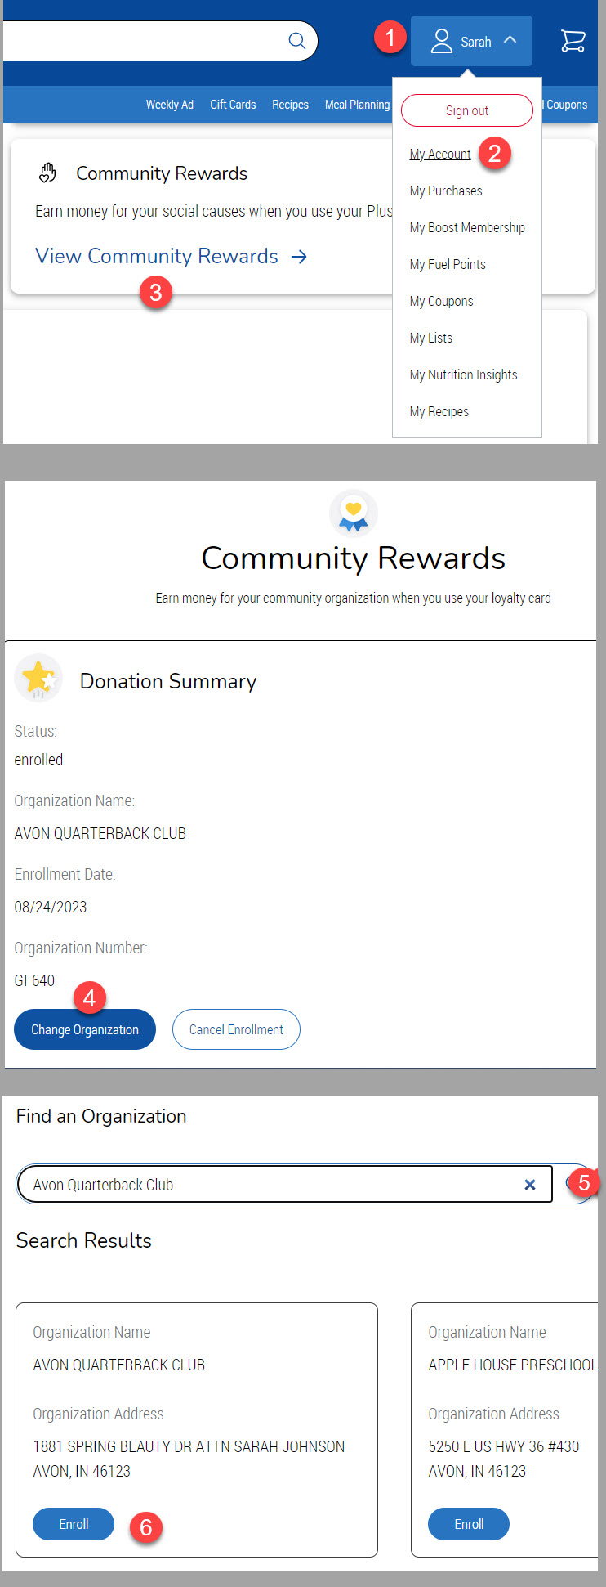

Subscribe to Club Calendar

- Go to the Events page on avonqbclub.com
- View the schedule by Day, Month, or a running list of upcoming events
- Click on an event for more details
- Subscribe to the calendar to sync it with your Google Calendar, iCal, Outlook, etc.

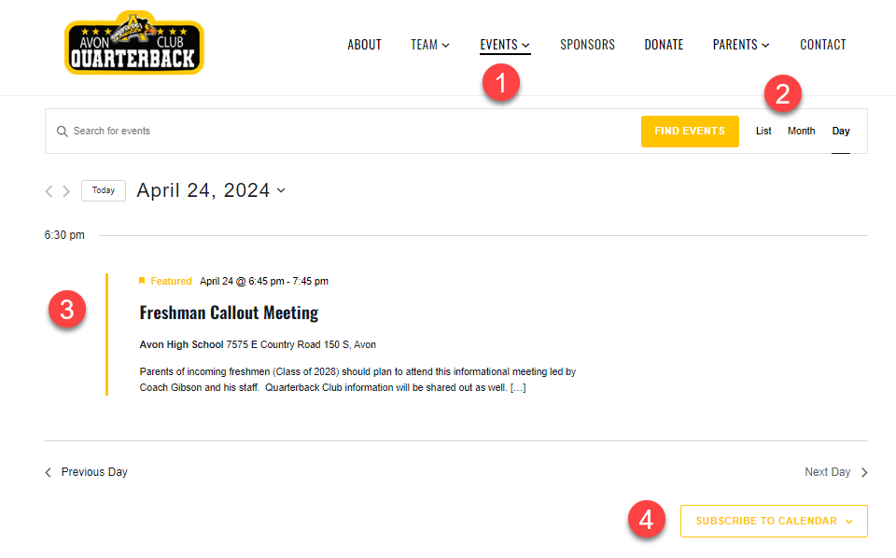


Fundraising Progress as of April 2026

Information about upcoming fundraisers is in this packet.
If we hit our goal as a team, there will be NO MEAL FEE this year!

